
Optical Flow Sensor (OFS) Technology
Air & Gas Flow Meters
5432 Any Street West, Townsville, State 54321 Tel 555.543.5432 Fax 555.543.5433
www.yourwebsitehere.cowww.opticalscientific.comm

Measurement is Not Affected By:

Distance, Pressure, Temperature, Gas Density, Moisture, Opacity, Differential pressure, Design DP, Beta Ratio, Gas Composition, Humidity, Speed of Sound
Flexible Installation
OFS can install in tight spaces with minimum space requirements of 2 upstream / 1 downstream diameters. No re-piping needed. Installation is to standard ANSI pattern 4” pipe flange. OFS can be installed on live process pipes using hot tap procedure and gate valves for isolation. No shutdown needed.

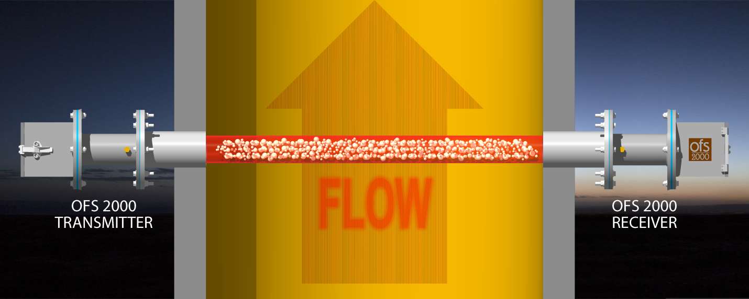
In 1981, Dr. Ting-I Wang, working at the NOAA ERL Wave Propagation Laboratory published a seminal paper: Wind Measurements By Temporal Cross-Correlation Of Optical Scintillations showing how this method could be used to measure changes in air flow by analyzing the movement of air through a beam of light.

In 1985, with a small group of other talented scientists, engineers, and technicians, Dr. Wang founded Optical Scientific, Inc. to develop this discovery. For several years the company engaged in design and development of a successful product line of increasingly sophisticated instruments to measure rain, snow, precipitation, and visibility. During this period OSI engaged in constant test and refinement of the software algorithms and manufacturing techniques, continuing to build its reputation for quality and accuracy. All this culminated in the introduction of the OFS 2000 Optical Flow Sensor in 1999.

All the discoveries and refinements that had gone before were adapted into this new sensor. This ground-breaking new instrument was introduced to the world market where it soon proved to be the sensor of choice for industrial customers concerned with Continuous Emissions Monitoring Systems (CEMS) to help reduce greenhouse gas emissions. As time went on further applications were found in power, petrochemical, and mining industries. Today, OFS 2000 systems are installed world-wide – every place where accurate flow monitoring is a critical factor.

Assures Compliance
All OFS 2000 sensors meet or exceed requirements set by the Environmental Protection Agency, and California’s South Coast Air Quality Management District.

EPA Method 14
EPA MACT RSR 40 CFR 63.670
EPA 40 CFR part 60 & 75
EPA 40 CFR part 60 sub part J & Ja
SCAQMD rule 1118

From the beginning, OSI has followed a policy of constant research, innovation, and improvement. Since OFS 2000 was introduced OSI has responded to customer needs with models to support a variety of industrial applications. The most recent release is the OFS 2000R, designed for steam-assisted refinery flare stacks. Further refinements are constantly in process.

Flexible Communication
All systems are equipped with 4-20mA Current Loop, RS-232/485, ModBus RTU data outputs, and can be configured with Serial port, Limited Distance Modem, and Fiber Optic Interface for any type of WAN or LAN.

No Moving Parts
OFS 2000 is essentially maintenance-free, save for window cleaning. OFS internal monitoring alerts the user if window cleaning is required. (Typically only semi-annually (if then) on the dirtiest stack and duct applications.)

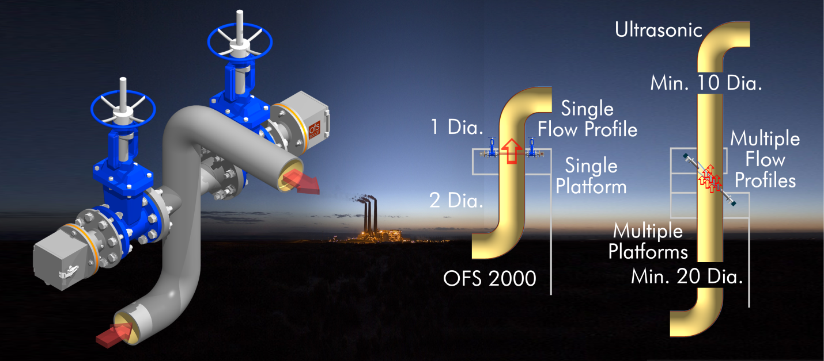

OFS How it Works:

OSI’s pateneted Optical Flow Sensor (OFS). Makes optical scintilation measurements across the entire distance between the transmitter and Reciever. It is the only flow sensor that gives a true non-contacting complete cross stack flow Measurement.

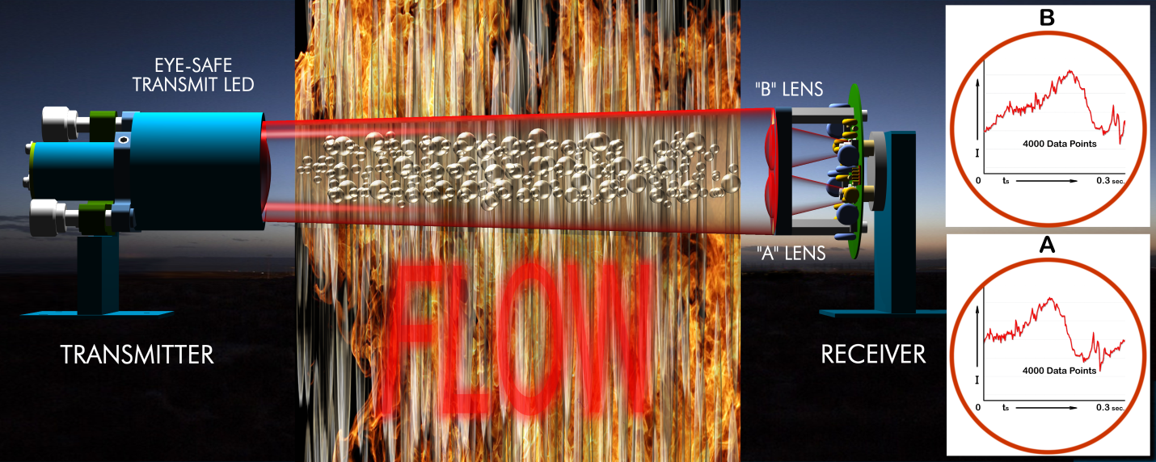

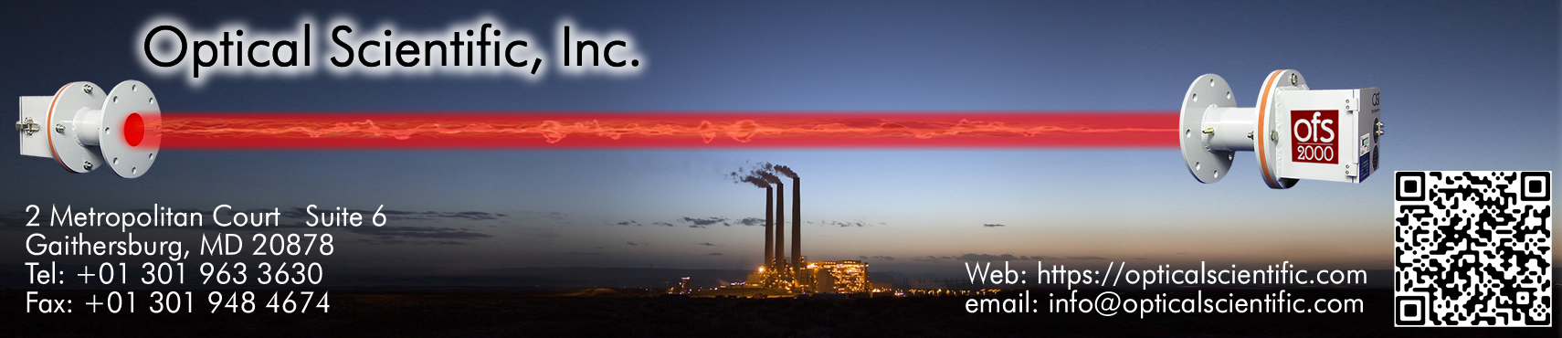

No Calibration Required

The simple fact is that by its very nature OFS technology does not drift.

This means all OFS models do not require calibration – ever! OFS technology uses a proprietary and patented algorithm that was developed by Optical Scientific and has been certified by NIST (National Institute of Standards and Technology). OFS technology is supported with over 20 million hours of observation data snf ford include Automatic calibration check and continuous self-test diagnostics are built-in for user security. Drift >3% from norm will cause a fault alarm. Since 1999 there have been no instances of calibration fault in any OFS system.
• .

Optical Detectiion
OFS technology relies on a patented optical scintillation measurement algorithum uses advanced Digital Signal Pocessing (DSP) to measure the movement of turbulence found in gaseous flow stream, providing accurate measurements. OFS takes 4000 data points every 0.3 seconds and measures the instantaneous average velocity

Non-Intrusive
No direct contact with flow media. Measurement is immune to the effects of temperature, gas density, moisture content, particulate count, or pressure. If OFS 2000 can detect the turbulence-induced light fluctuations with even a fraction of the light, it can accurately measure the flow velocity. It is, in this sense, a “pure” measurement.

Measures Volumetric Flow
Along with superior accuracy, OFS 2000 can also be configured with the ability to accept smart temperature and pressure sensor current loop data to calculate and report volumetric flow or mass flow in addition to velocity.

